Bash Script Tasks
- Create a bash script to check if a directory is available or not.
Outcome: checks for directory is available or not
Object ive: to check if a directory is available or not
Step by step manner:
- Create a file with a bash extension
- Edit the file with the desired script
- Then change the permissions and with the commands chmod
- Run the command ./1.bash or bash 1.bash
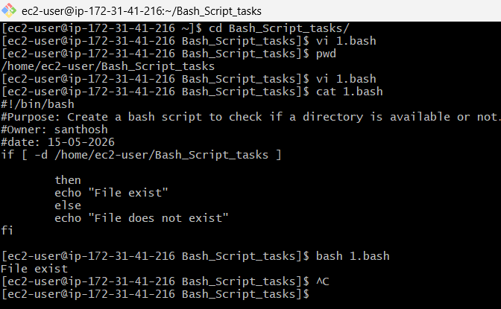
- Create a bash script to create multiple files.
Outcome: multiple files will be created
Objective: to create multiple files by using scripts
Step by step manner:
- Create a file with .bash extension to identify which we are using
- Edit the file with the script
- Change the permissions by using command -> chmod 755 files.sh
- Run the command ./2.bash to get the output of the script
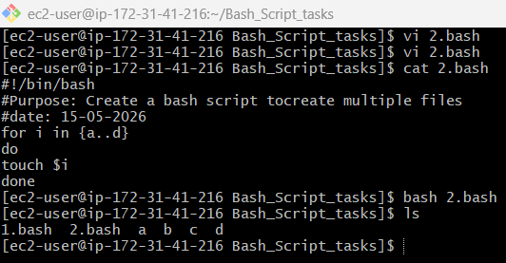
- Create a bash script to take a backup of a directory.
Output: backup of a directory is created
Objective: to create a backup of a directory
Step by step implementation:
- Create a file with .bash extension
- Edit the script in the file by using vi filename.sh
- Change the permissions with command chmod
- Run the command ./3.bash to get the output
- Create a bash script to install Nginx on an EC2 server.
Outcome: nginx is installed
Objective: to install a nginx on an ec2 server by using the bash
script
Step by step manner:
- Create a file with .bash extension
- Edit the file with the desired script
- Change the permissions by the command chmod
- Run command ./4.bash to install the nginx
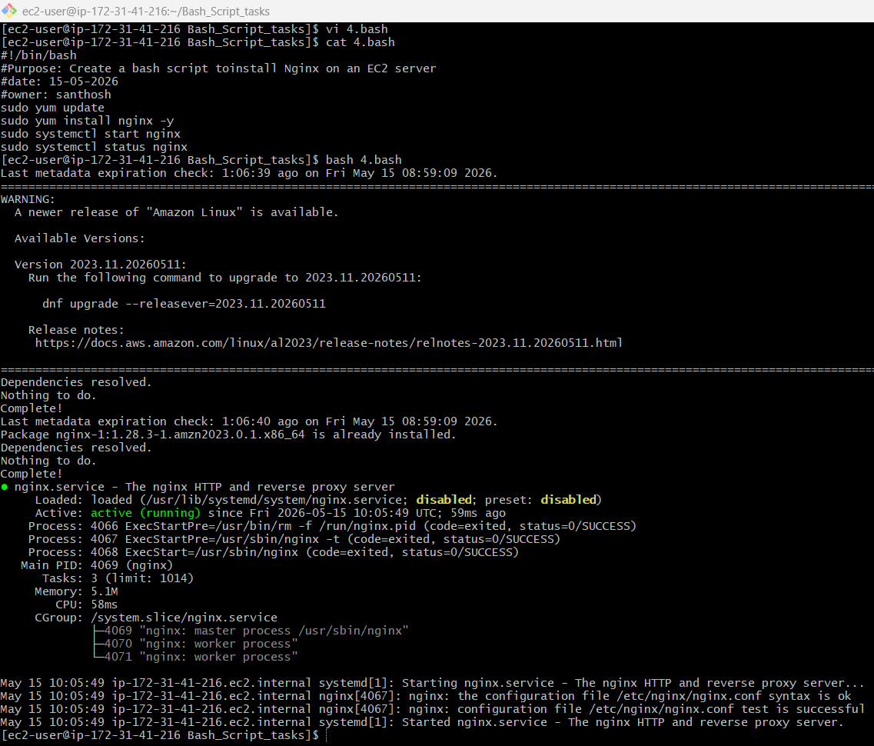
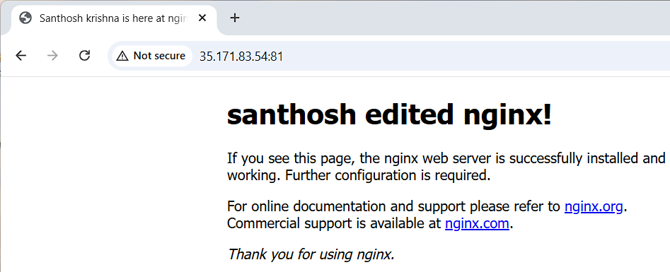
- Create a bash script to install Apache Tomcat on an EC2 server.
Outcome: apache tomcat is installed successfully
Objective: to install apache tomcat on an ec2 server
Step by step implementation:
- Create a file with .bash extension
- Edit the file with desired script
- Change the permissions by chmod command
- Run command ./5.bash to install tomcat
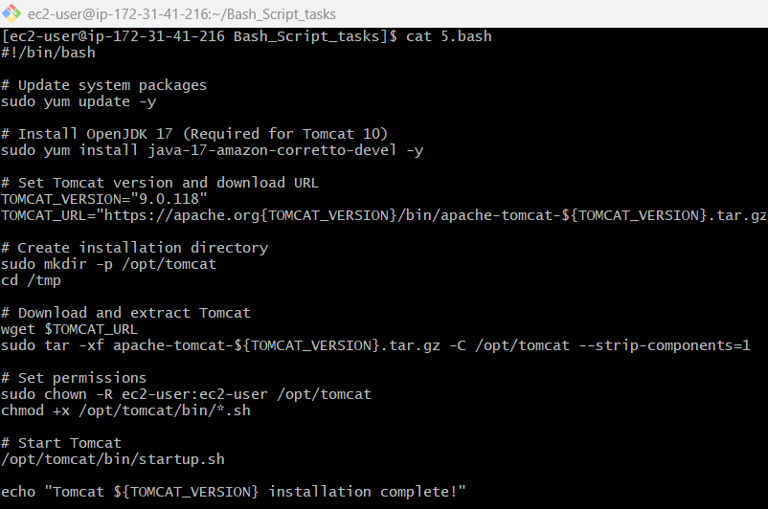
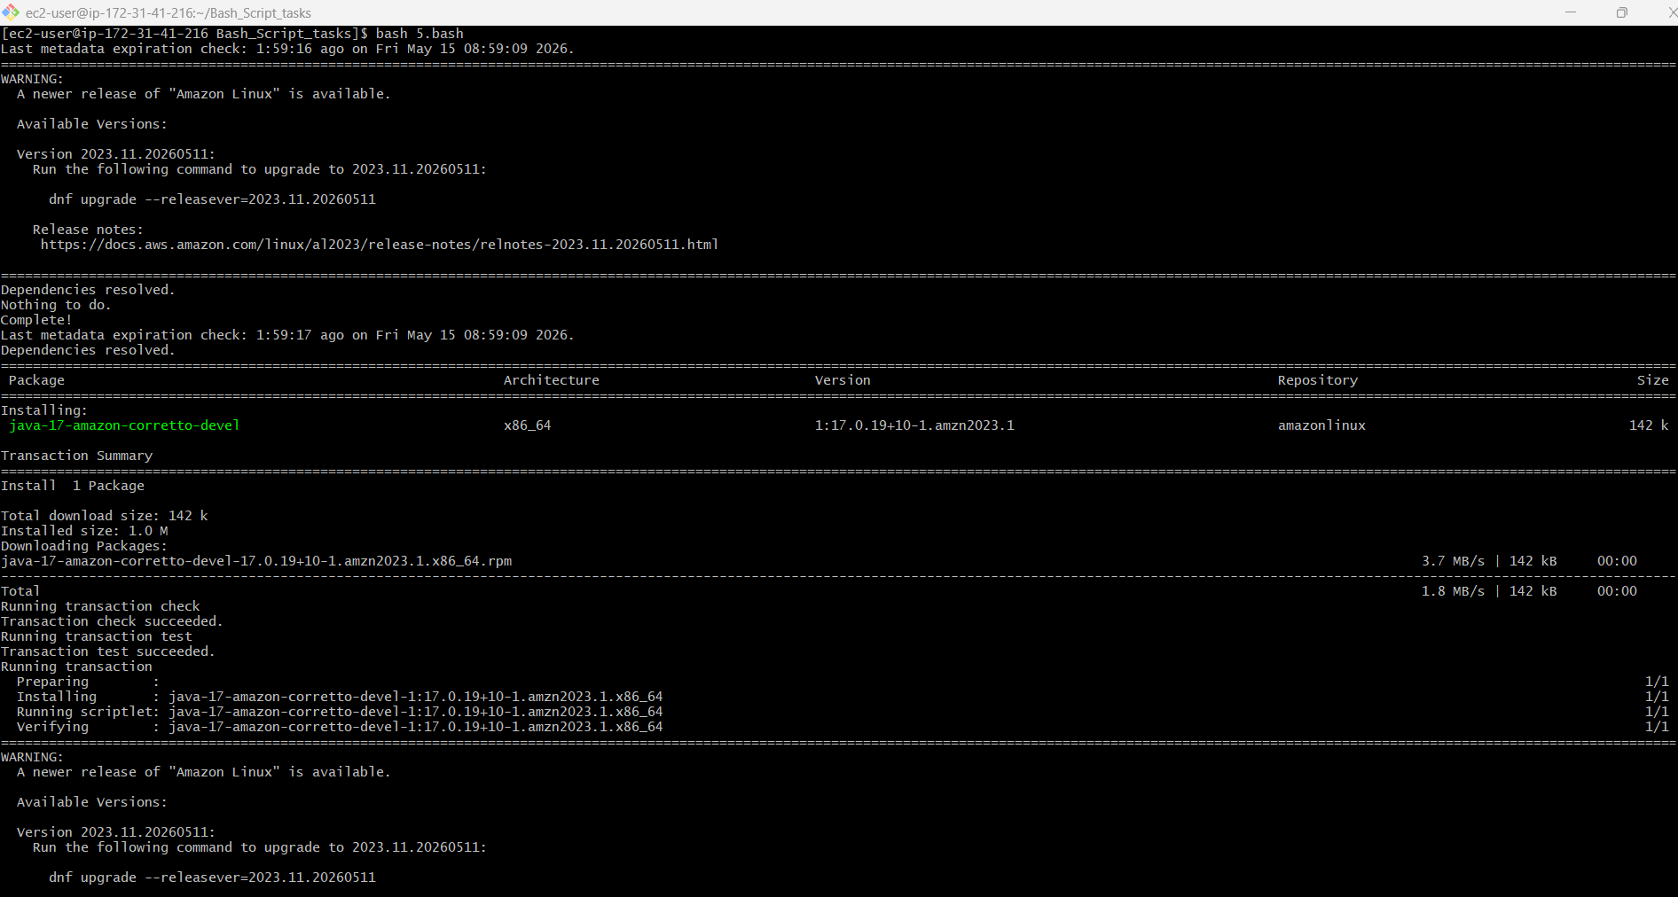
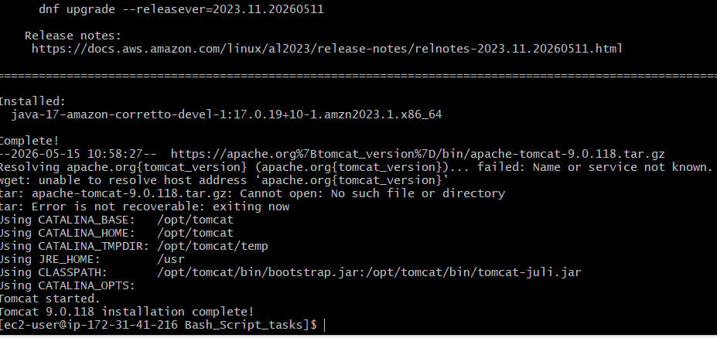
- Create a bash script to check if the Nginx service is running, if not running then script should start the service.
Outcome: nginx service is running
Objective: to check if the service is running, if not run the
service by the script
Step by step implementation:
- Create a file with .bash extension
- Edit the file with desired script
- Change the permissions with chmod command
- Run the command ./6.bash to get the output
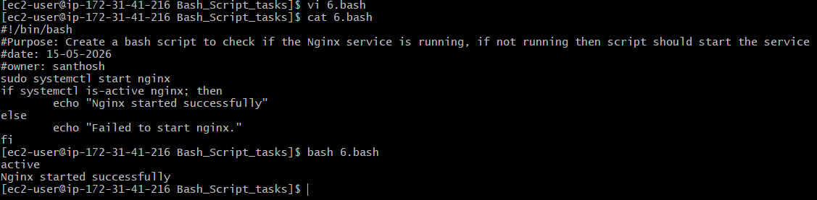
- Create a bash script for a calculator.
Outcome: calculator
Objective: to create a calculator
Step by step manner:
- Create a file with .bash extension
- Edit the file with desired script
- Change the permissions with chmod command
- Run the command ./7.bash to get the output
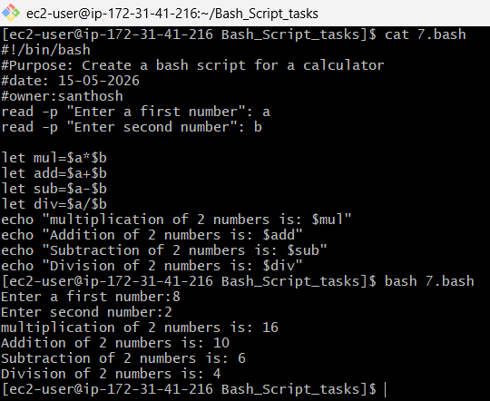
- Create a bash script to check if a directory exists, if not then create a directory.
Outcome: check if a directory exists or not
Objective: to check if a directory exists, if not then create a directory
Step by step manner:
- Create a file with .bash extension
- Edit the file with desired script
- Change the permissions of file with chmod command
- Run the command ./8.bash to get the output
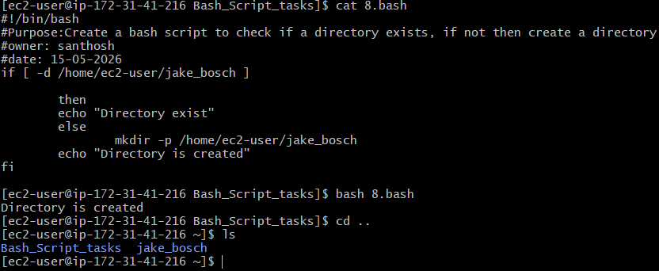
- Create a bash script to delete the last 3 lines of a file.
Outcome: last 3 lines were deleted
Objective: to delete the last 3 lines of a file
Step by step manner:
- Create a file with .bash extension
- Edit the file with desired script
- Change the permissions of file with chmod command
- Run the command ./9.bash to get the output
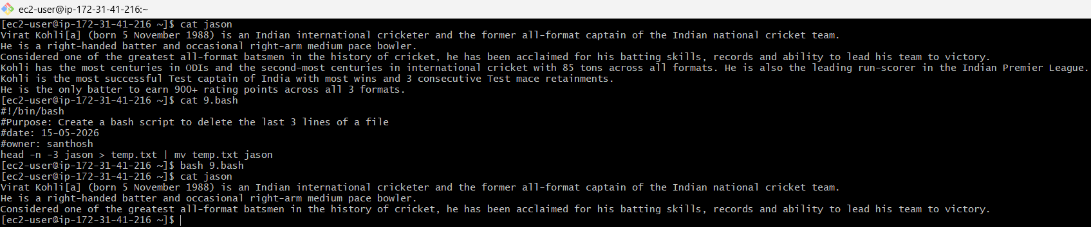
- Bash script to monitor cpu and if it is more than 80% then send email notification.
Outcome: if the threshold value is > 80% then email will be sent to
the given mail id
Objective: to monitor cpu
Step by step manner:
- Create a file with .bash extension
- Edit the file with desired script
- Change the permission with chmod command
- Run ./10.bash command to get the output
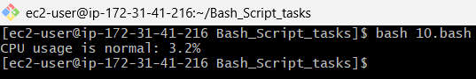
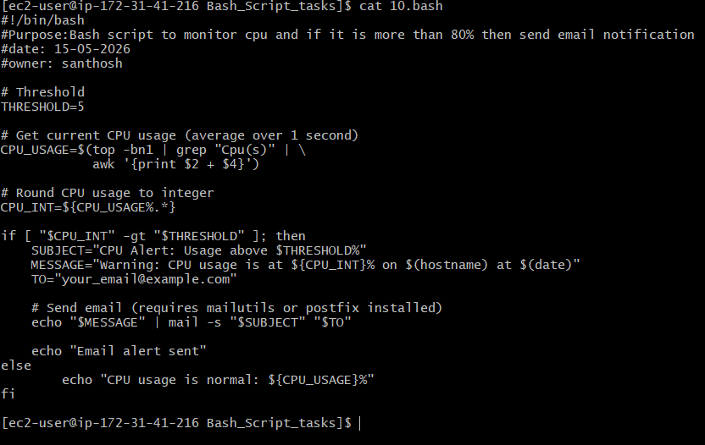

- Bash script to monitor disk space and if it is more than 80% then send email notification.
Outcome: if the diskspace value is > 80% then email will be sent to
the given mail id
Objective: to monitor disk space
Step by step manner:
- Create a file with .bash extension
- Edit the file with desired script
- Change the permission with chmod command
- Run ./11.bash command to get the output
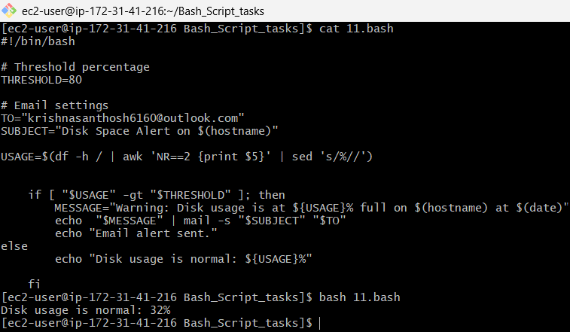

- Bash script to monitor memory and if it is more than 80% then send email notification.
Outcome: sent an email that memory is 80% full
Objective: to send a mail that your memory is more than 80% usage
Step by step implementation:
- create a file with .bash extension
- edit the file with desired script
- Change the permissions with chmod command
- Run the command ./11.bash to get the outcome
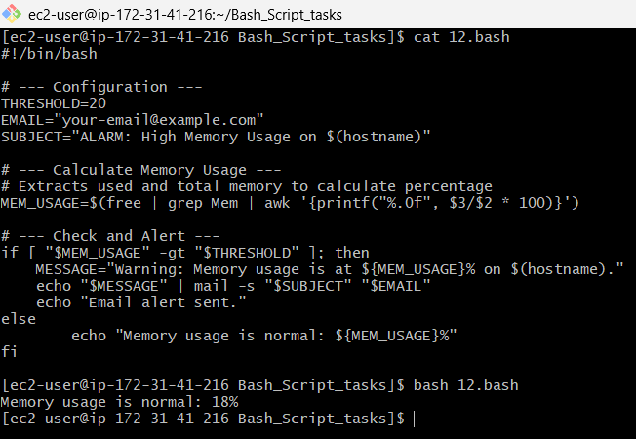

CRONJOBS :

Cron allows us to automate tasks by specifying the exact time and command to be executed. To run a job at a designated time, we provide its schedule and action in the cron configuration
